**Voluntary Service System (VSS) Enhancements**

**VSS*5*1**

**Release Notes**



Department of Veterans Affairs

Office of Information and Technology (OI&T)

Product Development

**Version: 1.3**

**December 2016**

Revision History

| Date | Version | Description | Author |
| --- | --- | --- | --- |
| December 16, 2016 | 1.3 | Revisions | VSS Technical Team |
| August 26, 2016 | 1.2 | Revisions | VSS Technical Team |
| July 13, 2016 | 1.1 | Revisions | VSS Technical Team |
| June 3, 2016 | 1.0 | Document Creation | VSS Technical Team |

Table of Contents

1. Introduction 1

2. Purpose 1

3. Audience 1

3.1 How to access VSS*5*1 1

3.2 Documentation 1

4. New Functionality or Functionality Changes 2

4.1 Home Page and Menu Structure 2

4.2 General Functions 2

4.2.1 Facility 2

4.2.2 Benefiting Services/Roles 2

4.2.3 Organizations / Local Branches 2

4.2.4 Combination Codes/Assignments 3

4.2.5 Requirements 3

4.3 Volunteers 3

4.4 Donations 4

4.5 Reports 4

5. Non-Functional Changes 5

6. User Access Levels 5

7. PIV Login 6

7.1 SSOi with PIV 6

7.2 Using VA Network ID and Password 8

7.3 Windows Authentication 10

8. Known Issues 11

List of Tables

Table 1: Standard Reports 4

Table 2: CRUD Matrix 5

# Introduction

The Department of Veterans Affairs (VA) Voluntary Service Office (VAVS) operates one of the largest volunteer programs in the Federal Government that supplements staff and resources in all areas of patient care and support. The mission of the VAVS office is to provide a structured volunteer program under the management of VA compensated employees in cooperation with community resources to serve Veterans and their families with dignity and compassion.

The Voluntary Service System (VSS) is an enterprise web application that allows staff to track volunteers and in which capacities they serve along with any organizations they serve on behalf of. VSS tracks all donations received into the VA and how the donated dollars are allocated.

Additionally, VSS has a subset of functionality that allows Volunteers to login, enter their time and print meal tickets available from the VAVS Personal Computer (PC) kiosks located at the volunteer facilities. This enhancement does not impact the previously established meal ticket printing ability.

# Purpose

VSS is currently in Production. The last patch implemented was VSS 4.04. VSS 4.04 was implemented for a .net application utilizing a Crystal reporting server. The VSS Enhancement (VSSE) project released in this patch will re-engineer the VSS product utilizing java and a Microsoft SQL Server Reporting Services (SSRS).

This document covers the newly added features and the changes to the current VSS functionality as implemented in VSS 5.1. The PC kiosks can now utilize all standard VA software. The baseline and setup for these kiosks is included in a separate installation document published by Enterprise Systems Engineering and Field Operations.

# Audience

This document targets users and administrators of VSSE and applies to the changes made between this release and any previous releases for this software.

## How to access VSS*5*1

The following new URL’s have been established:

Production Staff: <https://vaww.vss.med.va.gov/vss>

Production PC Kiosk: <https://vaww.vss.med.va/gov/vsskiosk>.

## Documentation

The VSS User Guide will provide summaries and step-by-step instructions for all VSS user screens. The intent of this document is to familiarize users with the functionality released in VSS*5*1.

Additional documents can be found on the VA Software Document Library at: <http://www.va.gov/vdl/application.asp?appid=135>

# New Functionality or Functionality Changes

## Home Page and Menu Structure

The VSS Home Page and Menus are new and accessed through a new URL. Each user must be assigned a role for each facility. Each role is allowed to perform specific features identified by permissions. The user may have a different role at each facility, if needed. VHA User Id and password is used for login.

## General Functions

### Facility

Station, institution, and site have been condensed to the term “Facility.” The original facility file has been matched through the station number to the VA Standard Data Services (SDS) Institution file. Some station numbers in VSS were updated to use the station number published in the SDS file.

Each facility now has the ability to establish a physical location(s). The main facility (usually a VA Medical Center) is known as the “Main Facility” when used in Benefiting Services. Each facility may need to establish a PC kiosk for volunteer time posting and meal ticket printing. Manual setup is required.

### Benefiting Services/Roles

Benefiting Services still exist at the National and Local level. National Administrators will maintain the National services. Facility Administrators have the ability to utilize National Services and to create local roles for National services to meet their specific needs. They may also create Local services and roles for their facility.

Benefiting Services now support roles. Roles are used to represent different jobs within each service. Each service has a “General” role type established. The existing time has been assigned to this “General” role for the previously existing service within each combination code.

The system will support the ability for the Site Administrators to merge multiple existing services (and their time) into a logically organized scheme. Refer to the User Manual or cheat sheet for help with this process.

Service Codes are removed and are now represented by Service Name.

### Organizations / Local Branches

National Organizations will continue to be established and utilized by all facilities.

Organization codes were removed and are no longer supported. The 100 local organization limits has been removed.

Local Branches can now be created and associated with a Local or a National Organization. Branches for national organizations are effectively treated by the system as local organizations in most situations.

Time and donations can now be assigned to local branches. For example: Instead of assigning time to “American Legion, volunteers can now assign their time to “American Legion – Post 500.”

Any organizations brought over inactive will have all associated time and donations set to “Read Only.” Any changes to any records associated to them will require reactivating the organization first.

### Combination Codes/Assignments

Combination codes have been removed from the system and replaced with Assignments. Assignments are comprised of a Benefiting Service, a Role, and a Physical Location. They are managed on the Benefiting Services screen. The Volunteer is designated with one or more Assignment’s that are utilized during time posting.

Assignments are no longer tied to specific organizations. Organizations are associated to the Volunteer and selected during time posting. The schedule has been removed.

All existing combination codes have been migrated in the form of Assignments. The role for existing combination codes is “General” and the physical location is the “Main Facility.”

### Requirements

The ability to track Volunteer requirements has been added and is established at the National or Local levels. Local requirements apply to all volunteers at the facility the requirement was created for.

## Volunteers

Volunteers have one (1) profile that is used across the enterprise. Each facility will share this information. The volunteer will have a primary facility designated for awards management, List of Excluded Individuals/Entities (LEIE) management and other functions that may be performed by a single facility.

Major features for Volunteers:

* Locally and National searches for existing volunteers.
* Removal of duplicate identifying codes. The Active volunteer who has volunteered the longest kept their code. Additional volunteers with duplicate codes were assigned a sequential number to the end of their code beginning with 0 based on seniority.
* Inactive vs terminated volunteers can now be identified through the Volunteer Status.
* Volunteer email addresses are collected.
* Requirements each volunteer needs to fulfill are recorded.
* Combination codes no longer need to be established and associated to each volunteer.

## Donations

Major features for Donations:

* A new donor type of “Anonymous” is available. Users can utilize this new anonymous donor type when entering anonymous donations. All Anonymous donations can be summed and reported.
* Users can indicate the Donor is also a Volunteer. Donations from volunteers can be summed and reported.
* Users can establish an organization as a Donor without re-entering address and contact information. The Organization information is retrieved and displayed on the Donor Profile. Dual entry/update of contact and organization information is no longer needed.
* Users can view all Donations for a Donor (nationally)
* Users can print the Donation Receipt, Memo, and Thank You Letter acknowledgements all at once after entering each donation or in a group.
* Facility Administrators can customize the Donation Thank You Letter for each facility.

## Reports

VSS uses SSRS to implement both canned and ad-hoc reports. When the report menu options are selected, the SSRS report interface is opened in a frame within the VSS application and is transparent to the user.

The following standard reports are available.

Table 1: Standard Reports

| **Report Name** | **Description** |
| --- | --- |
| National Official Address Labels | National Official Labels by Type, Organization |
| Voluntary Service Address Labels | Voluntary Service Staff Directory Label by Facility or State |
| Voluntary Service Directory | Voluntary Service Directory Detail or Summary By Facility, State, VISN |
| Donation Memorandum | Memorandum to print after donation(s) |
| Donation Receipt | Receipt to print after donation(s) |
| Donation Thank You Letter | Thank You Letter to print after donation(s) |
| Meal Ticket Report | Meal Ticket List by Day |
| Volunteer Address Labels | Volunteer Address Labels by Facility, Age |
| Grand Total Donations | Total Donations By Station |
| New Volunteer | Volunteers who have posted time for the first time |

An Ad-hoc reporting capability will be available to specific users.

# Non-Functional Changes

The following non-functional changes have been implemented

* Users can now export data grids and reports to word, pdf and excel.
* Report results can be saved.
* Users will automatically be logged out of the system after 15 minutes of inactivity.

# User Access Levels

VSS user access roles are defined and mapped as follows in the next table.

Table 2: CRUD Matrix

| **VSS 5.1 Role** | **Description** | **VSS 4.04 Role** |
| --- | --- | --- |
| National_Administrator | Person responsible for nationwide VSS administration including granting all levels of user access and maintaining all national lists and reports. | VtkNationalAdministrator |
| National_Specialist | Person responsible for assisting with nationwide VSS administration. Has read access to all of VSS but write access only to National Advisory Committee and Program Manager Databases. | VtkCOUser |
| National_User | Person responsible for assisting with nationwide VSS reporting. Has read only access to all VSS reports. | Not Applicable (N/A) |
| Site_Administrator | Person responsible for site level VSS administration to include granting user access at their site, maintaining lists for their site, volunteer management at their site and donation tracking. | VtkSiteManager |
| Site_Specialist | Person responsible for assisting with site level VSS administration. Has read and write access to volunteer, timekeeping, and donation records and reports. | N/A |
| Site_User | Person responsible for timekeeping and Donation Tracking at their site. Has read and write access to timekeeping and donation records and reports and read only access to volunteer records. | VtkSiteUser |
| Volunteer | Person responsible for logging their own volunteer hours and printing their own meal ticket at their assigned site(s) through the PC kiosk. | N/A |
| N/A | Not used | VtkSiteUserAdministrator |
| N/A | Not used | VtkCOUserAdministrator |

# PIV Login

Users can access VSS using a web browser via single sign-on capabilities. Single Sign-On Internal (SSOi) is an authentication service provided by Identity Access Management (IAM) and designated for operations-based applications such as VSS.  This service provides an extra layer of security when accessing the application, while reducing time associated with multiple logon/logoff activities. A PIV card is required, unless an exception to use VA User Credentials is allowed.

* Upon successful login, the user is directed to the **Select/Change Facility Screen** or to the **VSS Web Home Page**.If a user is assigned to multiple facilities and has not yet selected a default facility, the user must select the appropriate facility before proceeding.
* Refer to **Select/Change Facility** section for additional information. If a user is only assigned to one facility, the **VSS Web Home Page** displays for that facility. Once a user has selected the default facility, the **VSS Web Home Page** displays it. The system then uses this Facility in all subsequent functions.

## SSOi with PIV

* + 1. Ensure your PIV card is inserted.
    2. Using the web browser, access VSS through URL:

https://vaww.vss.med.va.gov/vss

* + 1. The **VA Single Sign-On Screen** displays. Click **Sign In with VA PIV Card**.
* If the **VA Single Sign-On Screen** is notdisplaying using Internet Explorer, ensure SSL 2.0 and SSL 3.0 are unselected. Click the **Tools** icon in the top right hand corner of your browser and select **Internet Options**. Click the **Advance** tab and ensure the options are unselected.

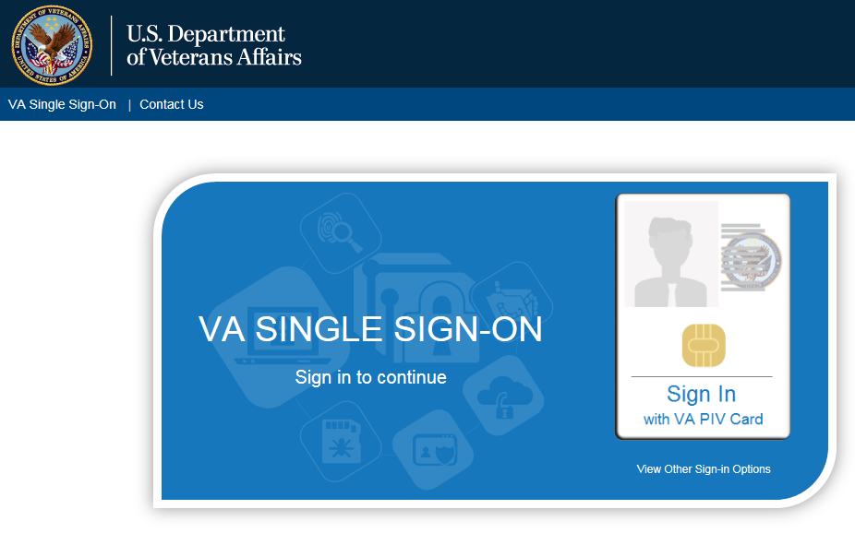

* + 1. The system will verify and read the PIV card. If found, the **Windows Security** box displays with the list of certificates associated with the PIV card.
    2. Select the **certificate** and click **OK** to display **the ActivClient Login** window.

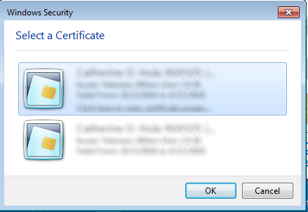

* + - * If more than one certificate displays, select **Click here to view certificate properties** link to display the **Certificate Details** box. Select the Certificate Path tab and scroll to ensure the certificate ends **internal PIV Authentication**.

Certificate Details box


* + 1. Enter your **Pin Number** and click **OK**.
  + If the incorrect Pin Number is entered, an error message displays and the user has six more attempts before being locked out and will need to be unlocked by calling the VA National Service Desk at 1-888-596-4357.

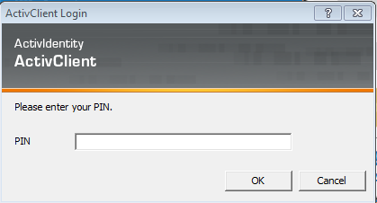

* + 1. Once the system verifies the PIV card and Pin Number match, the **Select/Change Facility** **Screen** displays or the **VSS Home Page**.
  + If the user is *only* authorized to a single facility, the System defaults to the authorized facility. The user does not have to select it upon login. The System recognizes this access and uses the selected facility in all subsequent functions
  + If the user is authorized to access multiple facilities:
    - If the user has previously selected a default facility, the user does not have to select a facility upon login. The System defaults to the specified default facility and uses this facility in all subsequent functions

## Using VA Network ID and Password

In some cases, a user may sign-in with their **VA Network Username** and **Password**. This is only to be utilized when a PIV exemption is required. User must call VA Help Desk and request this exemption for this option to be utilized

* + 1. On the **VA Single Sign-On Screen**, click the **View Other Sign-On Options** link to display the **VA Single Sign-On** box.



* + 1. Click **Sign in with** **VA Network ID**.

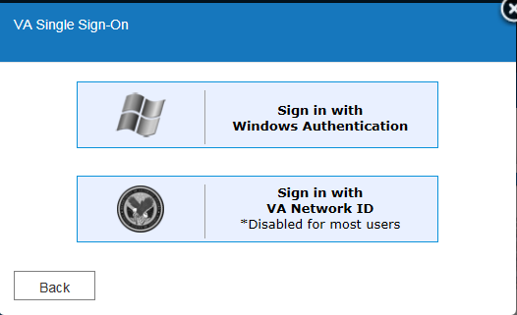

* + 1. **The VA Single Sign-On** box displays text boxes to enter your **VA Network ID** and **Password**. Click **Sign-In**.

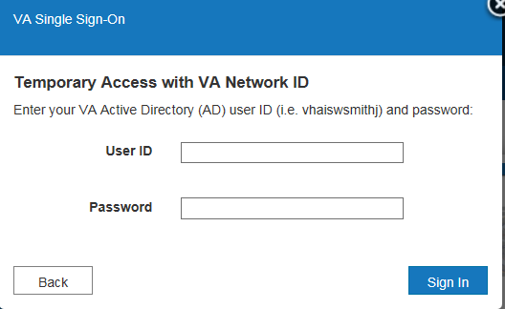

* + 1. The system will verify the user and be redirected to the **Select/Change Facility Screen** or the **VSS Home Page**.

## Windows Authentication

* + 1. On the **VA Single Sign-On Screen**, click the **View Other Sign-On Options** link to display the **VA Single Sign-On** box.



* + 1. Click **Sign in with Windows Authentication**.



* + 1. The system will verify the user and be redirected to the **Select/Change Facility Screen** or the **VSS Home Page**.

# Known Issues

There are no known issues specific to this release.